IPRO SUMMARY

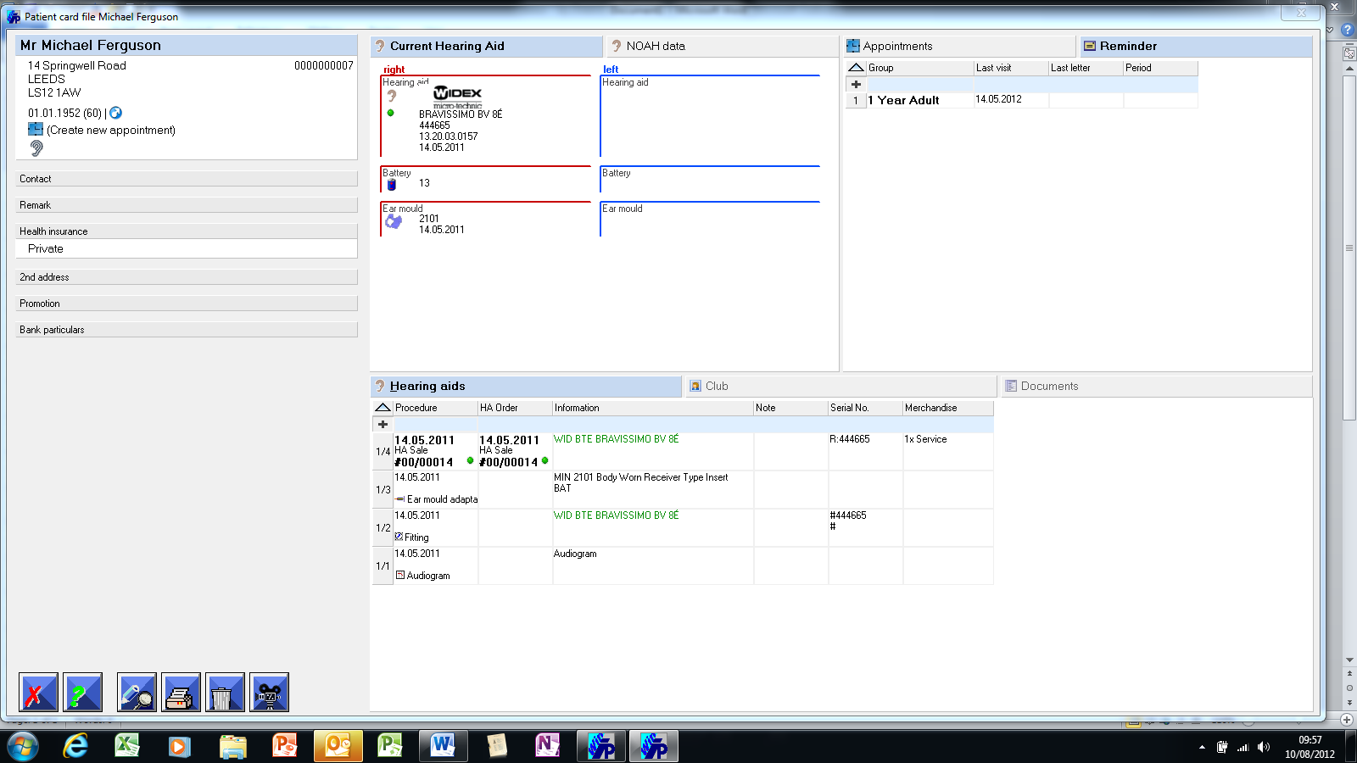
PATIENT CARD FILE
- Database is on the hard drive or server. No internet connection is necessary to access the database, which is very important for Domi visits. This does not prevent us being able to Multi-branch network, using the internet for communication between the branch servers.
- The system can be password protected by User and/or function.
- There is a back-up facility onto any media and the process can be automated.
- Master Data and system parameters, such as preferred supplier information, employees and working patterns, letter templates etc. will be set up in consultation with the customer.
- Full flexibility of VAT set up in System Parameters.
- Easy creation of new record or location of existing.
- Postcode look-up facility.
- Automatic calculation of age based on DOB.
- At a glance patient symbols, fully customisable, eg symbol to show they are a high value customer.
- Address quality options for recording ‘invalid address’, ‘deceased’ etc.
- Second address facility for separate billing, delivery or GP details.
- Opt in/Out function for mailing activity, which can be printed and signed.
- Loyalty card recording facility.
- Patient Characteristics – Capturing 4 customisable key pieces of information about the customer, which can be used for Patient Promotion.
- CRM Mark – Detailed lifestyle questionnaire, which can be used for Patient Promotion.
- Record of bank details if direct debit facility required.
- Free format remarks facility.
- Logical layout - Left of screen about the patient. Right of the screen is about the activity with the patient.
- Details of current Hearing Aid at a glance.
- Direct access to Appointment scheduler with visibility of appointment history
- Recall and Reminder with visibility of group selection
- Hearing Aid dispense with visibility of history.
- Club Management with visibility of summary of arrangement.
- Documents Management, enabling scanning or importing in of any other patient related document to reduce paper record keeping. Can also store JPEG images and has the ability to also take free format notes.

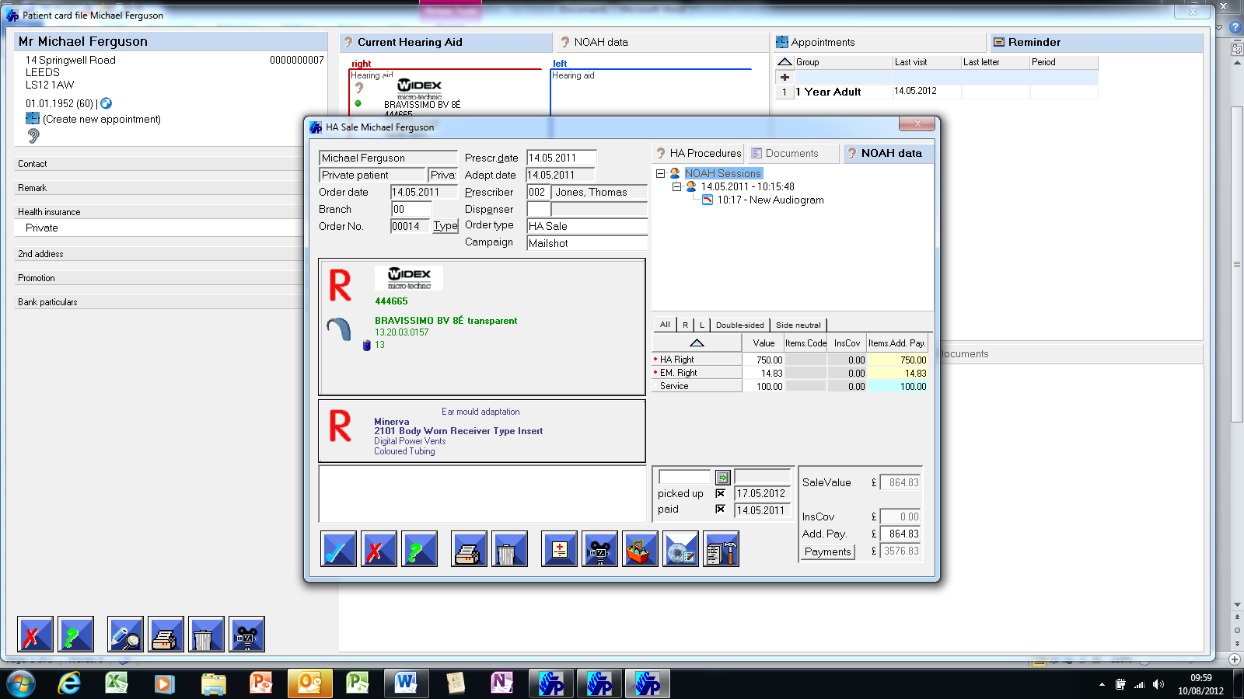

HEARING AID DISPENSING
- Access to History and Symptoms, which is free format and printable.
- Fully integrated with NOAH, meaning no duplicate entries, patient details automatically transferred into NOAH and NOAH audiograms automatically pulled into IPRO.
- Direct access to previous Noah sessions if required.
- All catalogues are fully downloaded into programme, so information is instantly available about the hearing aid.
- Any product not listed can be entered and will be retained in the memory.
- Prices can be pre-determined in stock module, or be freely input/amended during the dispense.
- Other price lines can be added for ancillary or service items.

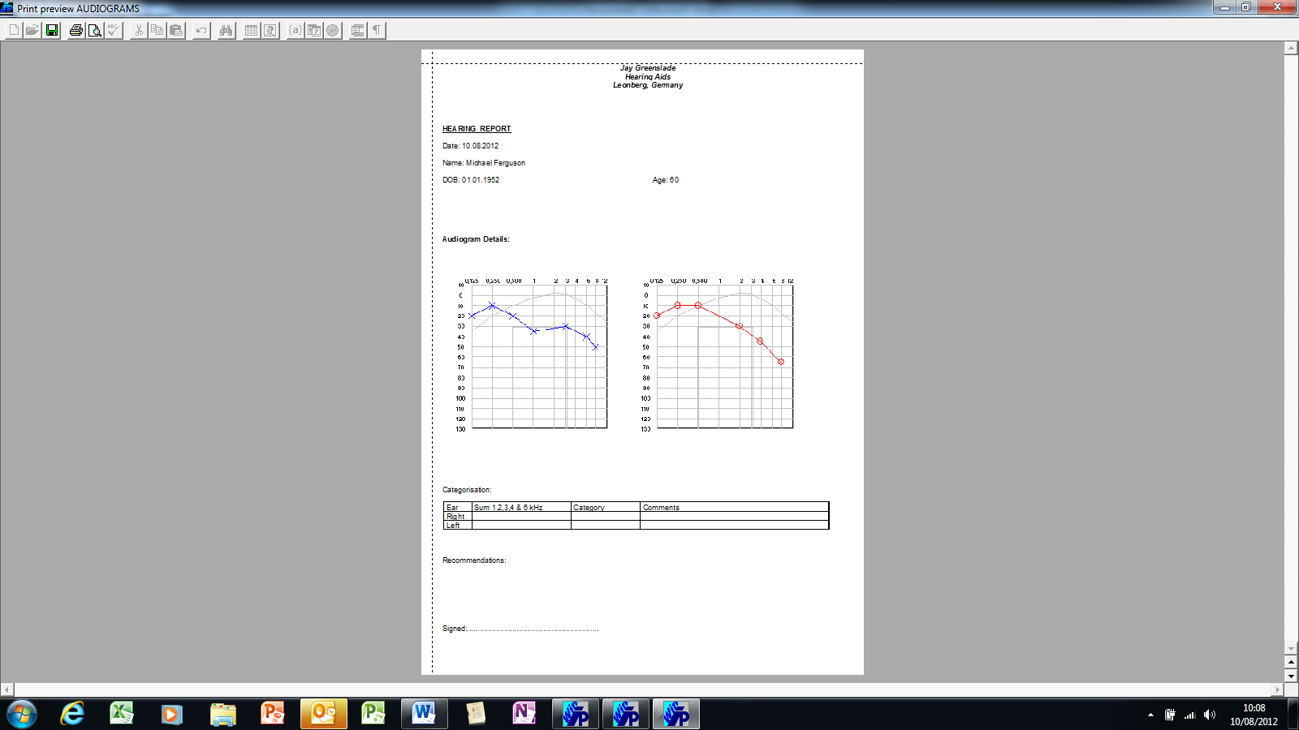
WORD PROCESSOR
- Fully integrated word process, where any form or letter can be set up, pulling data from IPRO fields. Example of letter above shows a letter that can be used for a referral to ENT, where audiograms are pulled through.

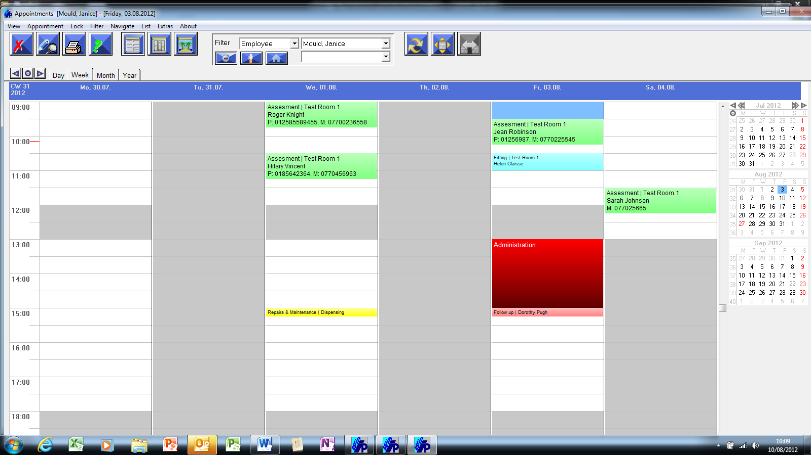
APPOINTMENT SCHEDULER
- Appointment Scheduler accessed from patient card file, or card file accessed from diary.
- Fully customisable by Room, Employee and Branch.
- Fully customisable Appointment types and durations.
- Colour coded diary view based on appointment type, employee or rooms.
- Holiday planner included.
- Can be synchronised to an outlook diary or exported via iCal.
- SMS and email appointment reminder system.
- At a glance summary of appointment statistics.
- History of appointments visible from patient record.

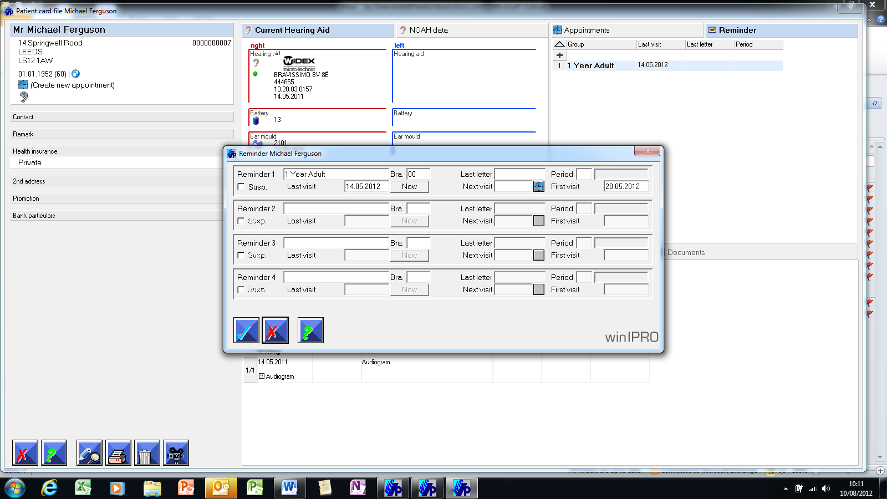
RECALL/REMINDER
- Summary visible from Patient Record.
- Up to 4 categories of reminders possible for each customer.
- Up to 99 reminder types possible per category.
- Up to 5 reminder timescales possible.
- Touch of a button facility putting patient into an automatic cycle.
- Fully customisable letters per category, type and timescale.
- Easy print facility for all letters due.
- Ability to remove customers from mail run.
- Ability to temporarily suspend patient from reminders.

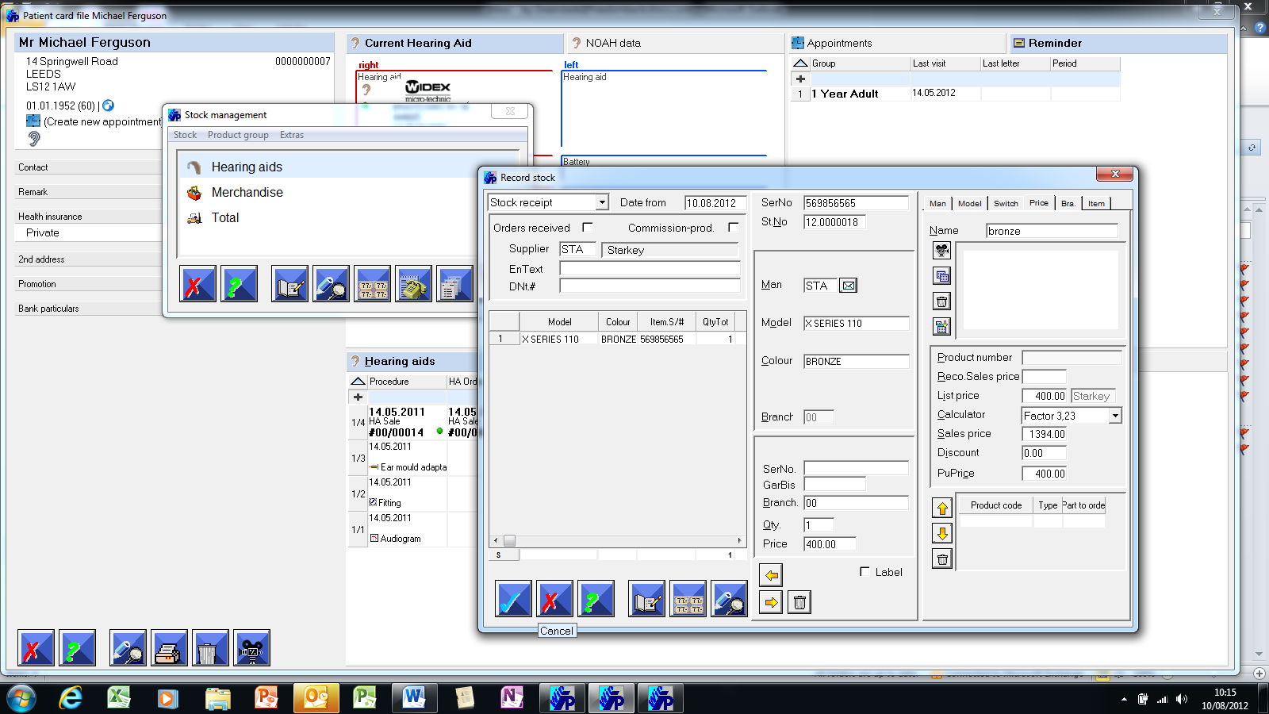
STOCK CONTROL
- Full catalogue lists available, showing all details of hearing aids.
- Delivery note recording.
- List price, Sales Price and Discount parameters defined.
- Stock analysis facility.
- Automatic memory of adhoc entries.

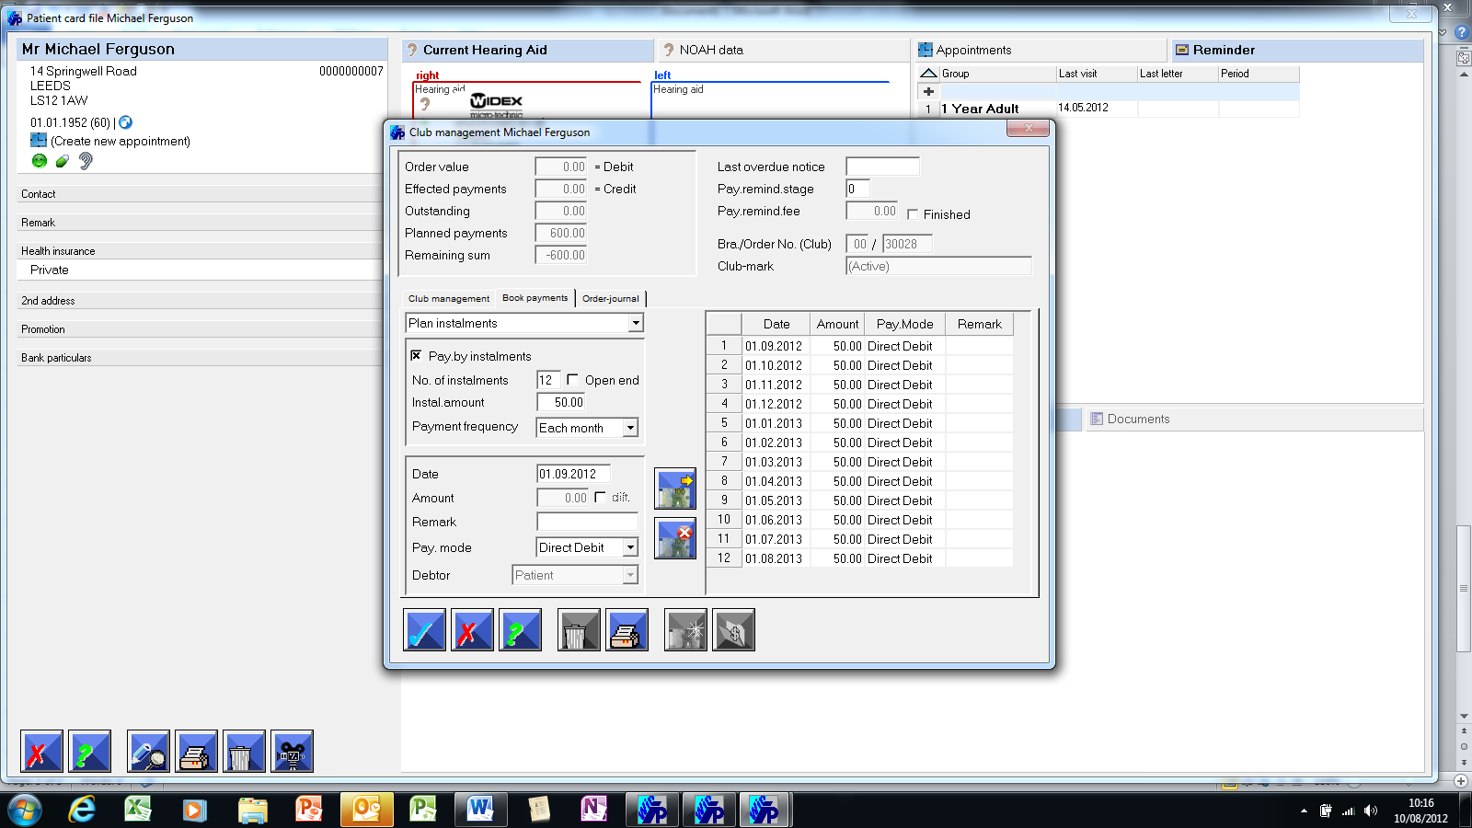

CLUB MANAGEMENT
- Club Management option is available.
- Can set up unlimited number of ‘Clubs’.
- Uses order status control function for managing Clubs at a glance.
- Can define instalment payments and payment types.

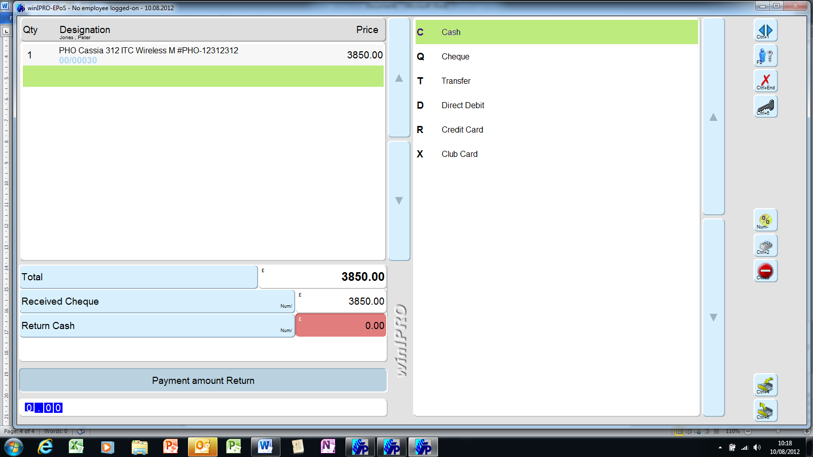

EPOS
- Easy retrieval of customer record.
- Pre-payment facility.
- Ancillary products easily added to transaction.
- Cash change automatically calculated.
- Discount facility.
- Can link to physical till and printer on payment entry.
- EPoS Journal of payment activity broken down into credit/debit terms.
- Cashing up totals.
- Summary of Accounts.
- Summary of Turnover.
- Exportable to excel.
- Interface to other cash book accounts systems possible.

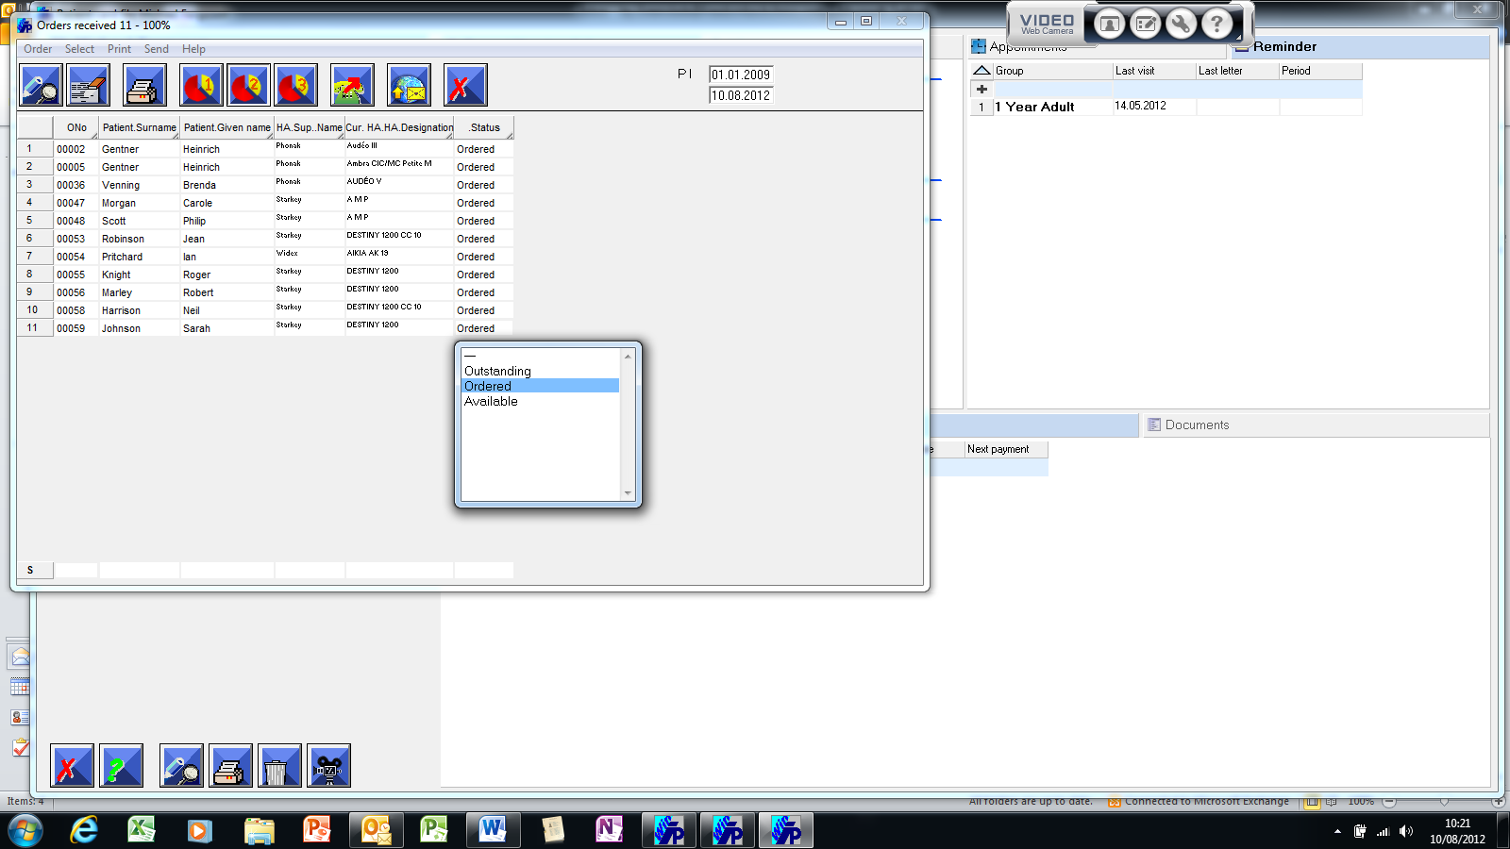

ORDER STATUS CONTROL
- List format view of all Hearing Aid orders.
- Up to 3 list categories can be defined, e.g., Orders to make, orders received, orders collected.
- Can edit the list directly, which automatically updates in customer record.
- Columns can be customisable to show any required information, e.g. Supplier and customer telephone number.

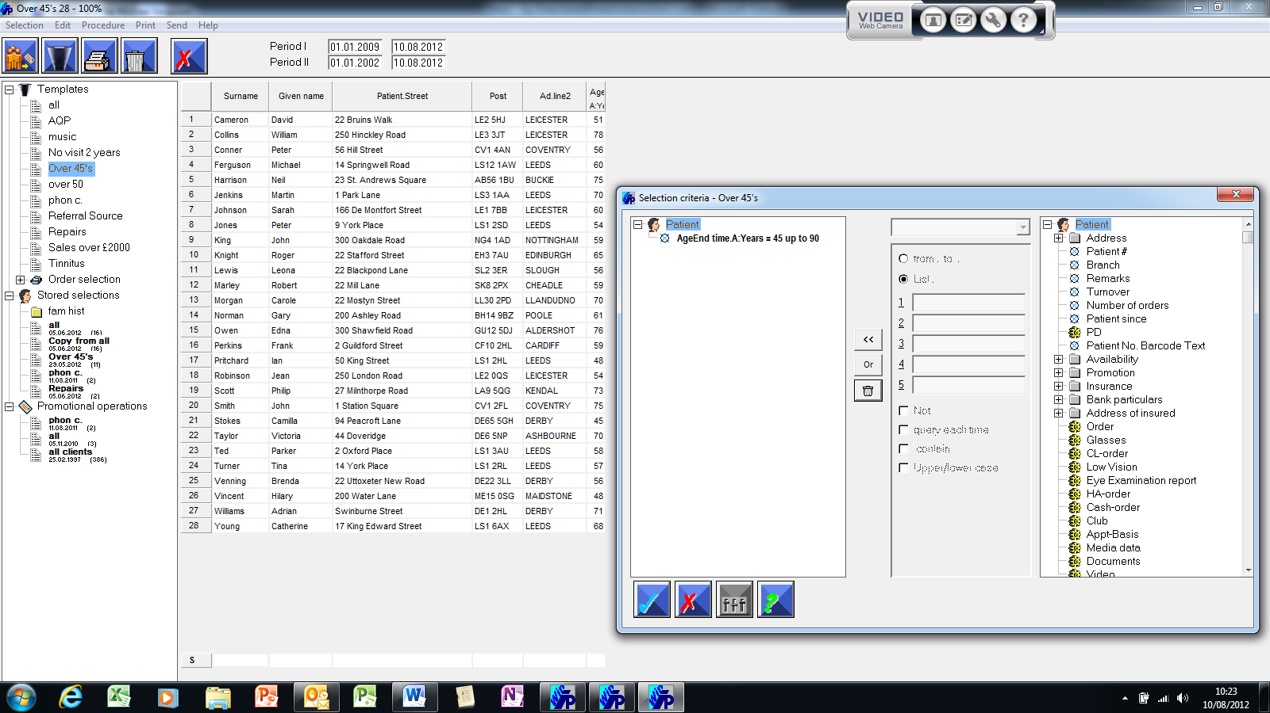

PATIENT PROMOTION
- Create target lists based on any data field or multiple data fields within the programme.
- Analyse post activity success through achieved turnover.
- Tailor any letter within the word processor for the campaign.
- Export lists to third parties if required.

